|  |  |
| --- | --- |
| EGC_Black | Student Name \_\_\_\_\_\_\_\_\_\_\_\_\_\_\_\_\_\_\_\_\_\_\_    **Eastern Goldfields College**  Mathematics 2015  Test 3 – Calculator Free1 |
|  | **Total Marks: 39 marks** |

**Time allowed: 40 minutes**

**No calculator or notes permitted for this section.**

***Answer all of the following questions. Show all working to obtain full marks.***

**1.** **(7 marks: 1, 2, 1, 1, 1, 1)**

**    **

****

Using the matrices given above, calculate the following. Where the operation is not possible, provide an explanation.

|  |  |
| --- | --- |
| a) E + A | b) DC |
| c) A2 | d) 3B |
| e) FB | f) F3 |

**2.** **(1 mark)**

Determine the price to earnings ratio for a share with a price of $6.00 and dividends in the last twelve months totalling 75 cents per share.

**3. (2, 2 marks)**

The figures below are similar.

a) The surface area of the smaller cylinder is 25 mm2. What is the surface area of the larger cylinder?

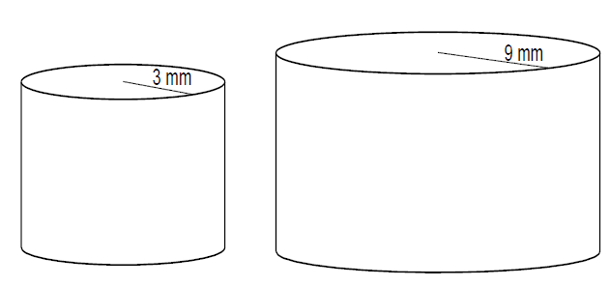

b) The prisms below are similar.

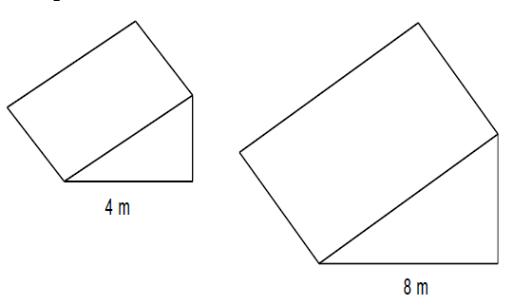

The volume of the larger prism is 800 m3. What is the volume of the smaller prism?

**4. (2, 2, 2: 6 marks)**

For the following sets of triangles, determine whether or not they are similar and justify your answer with a reason.

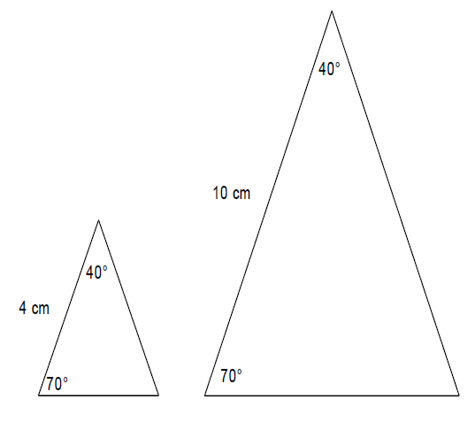

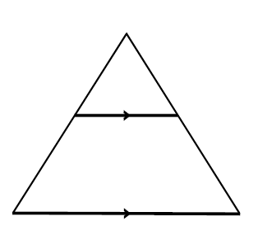

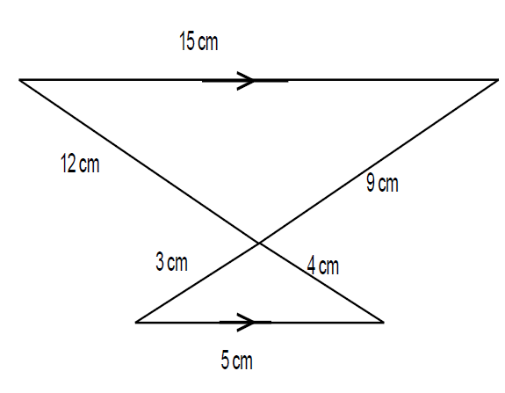

c)

**5. (3, 3: 6 marks)**

Each of the following triangles **are** **similar:**

Calculate the value of the unknown variable in each.

1. 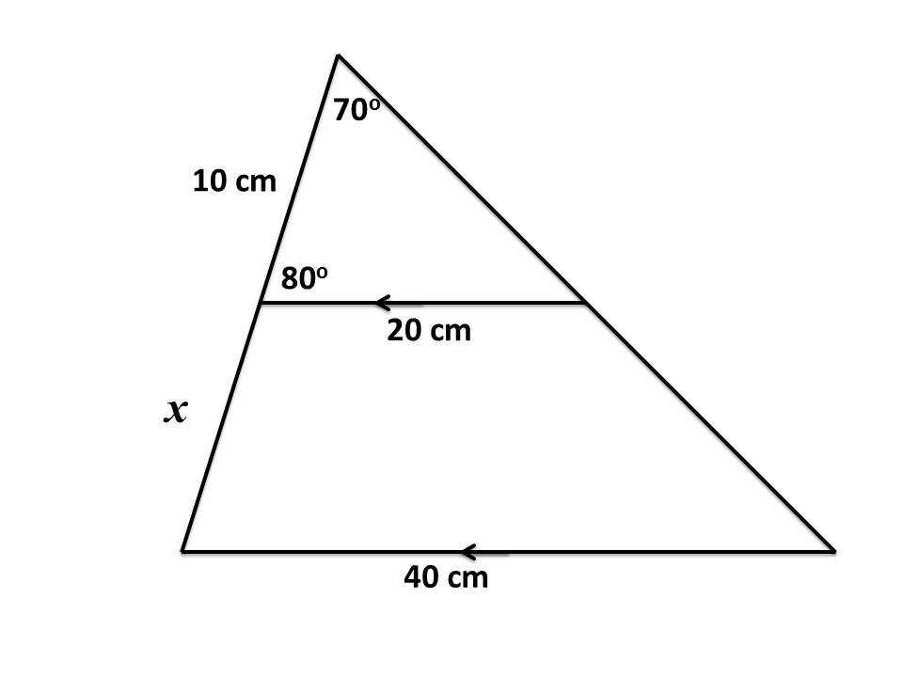

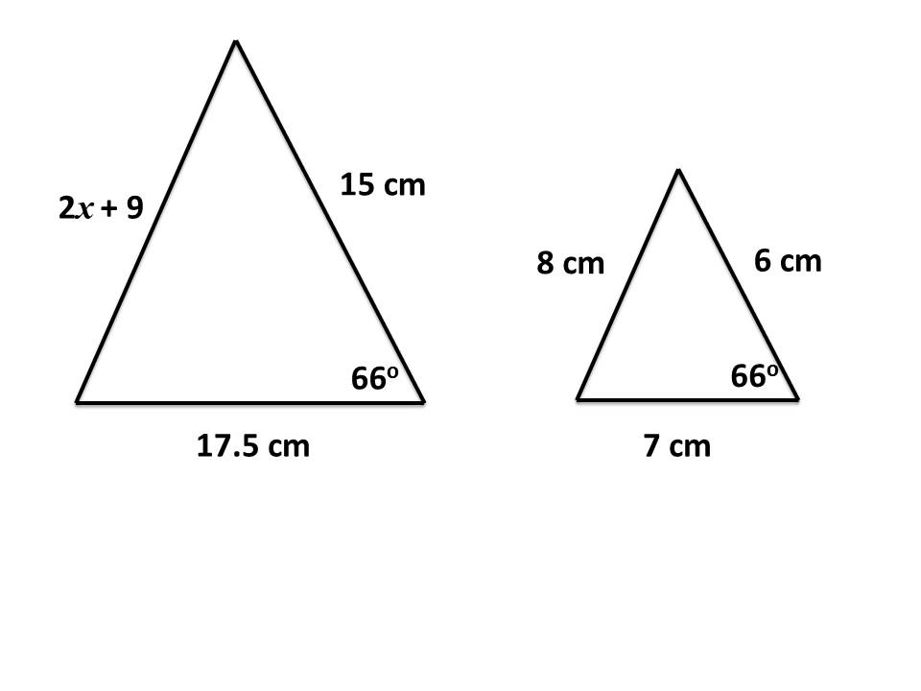

**6.** **(3, 2: 5 marks)**

The following is a network showing who has who‘s mobile numbers.

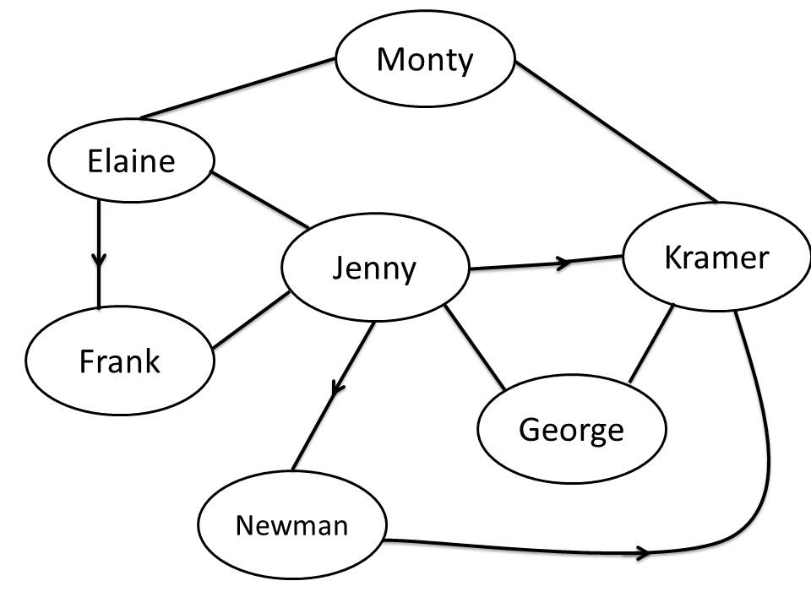

1. Complete the matrix below to represent this information using zeros to show where someone does not have someone else’s mobile number, ones to show where someone does has someone’s mobile number and zeros on the leading diagonal so that the situation of having one’s own mobile number is not counted.

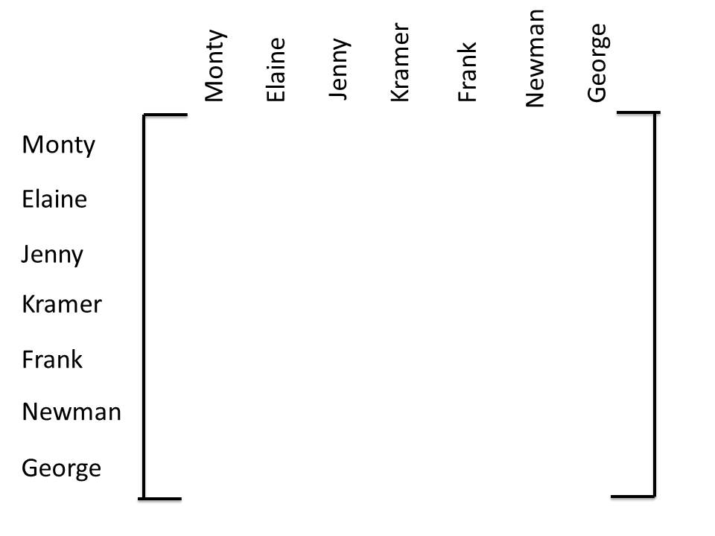

1. Create a matrix to show how many ways each pair can communicate with each other via a third person.



**7. [2, 2: 4 marks]**

Charlene was calculating with matrices. She got the following answers incorrect. Explain what she did wrong and write the correct solution.

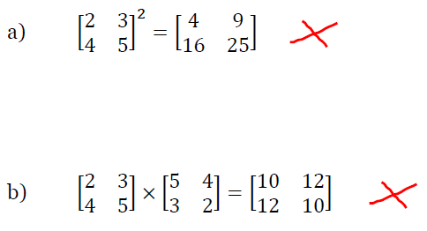

**8. (2, 2, 2: 6 marks)**

Are the following statements true or false? Explain your answer.

a) If 𝐴 = [1 1] and 𝐵 = [1 1] then 𝐴𝐵 = [1]

b)

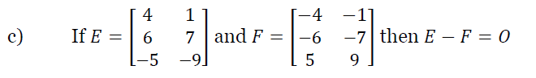

|  |  |
| --- | --- |
| EGC_Black | Student Name \_\_\_\_\_\_\_\_\_\_\_\_\_\_\_\_\_\_\_\_\_\_\_    **Eastern Goldfields College**  Mathematics 2015  Test 3 – Calculator Assumed1 |
| **Time allowed: 20 minutes** | **Total Marks: 20 marks** |

**9. (3 marks)**

Gen is 19 years old and still lives at home. She works part-time earning $23.50 per hour for 11 hours per week. Gen is seeking Youth Allowance to top up her fortnightly income whilst she lives at home.

|  |  |
| --- | --- |
| Status | Fortnightly Payment |
| Single less than 18 years living at home | $226.80 |
| Single less than 18 years not living at home | $414.40 |
| Single older than 18 years living at home | $272.80 |
| Single older than 18 years not living at home | $414.40 |
| Single with children | $542.90 |

Youth Allowance students can earn an income but this reduces the fortnightly payment according to the table below:

|  |  |
| --- | --- |
| Income / fortnight | Reduction in fortnightly payments |
| Over $415 - $498 | 50 c in the dollar |
| Over $498 | 60 c in the dollar |

Given the tables above, ***determine*** the amount of Youth Allowance paid fortnightly considering Gen’s part-time work.

**10. (2 marks)**

The following hemisphere has a volume of 150 cm3.

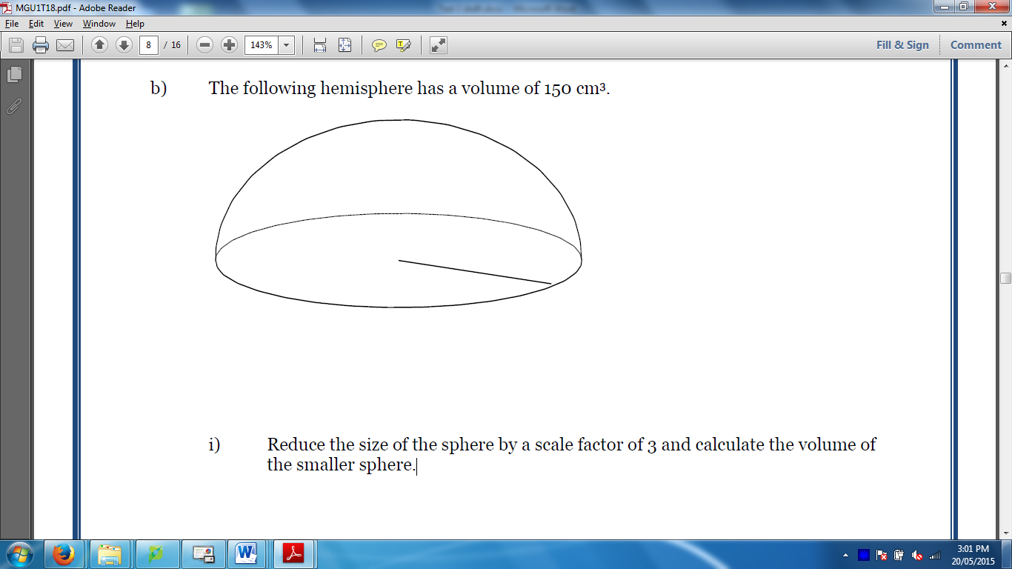

Reduce the size of the hemisphere by a scale factor of 3 and calculate the volume of the smaller hemisphere.

**11. (6 marks: 2, 2, 2)**

John wants to see which of the two banks in his portfolio of shares the better performer is, and he decides to use the P/E ratio to compare the two banks.

$$P/Eratio=\frac{Market price per share}{Annual earnings per share}$$

AAA Bank’s shares are currently $33.65 while ZZZ Bank’s shares are currently $32.055.

AAA Bank has annual earnings of 207.5 cents per share.

ZZZ Bank has annual earnings of 223.1 cents per share.

1. Calculate the *P/E* ratio for each bank

b) Make a recommendation as to which bank John should buy more of, if the P/E ratio was the only indicator to be used. Justify your recommendation.

c) Dividends from both banks are paid twice a year and in the last year AAA Bank gave dividends at 82c and 84c per share. What percentage of its annual earnings does AAA Bank distribute to shareholders?

**12**.  **(4 marks: 1, 1, 2)**

Three friends went on a trip overseas and brought back some unspent foreign currency which they need to exchange back to Australian dollars (AUD).

They have made a table showing the amounts of each currency they each have.

|  |  |  |
| --- | --- | --- |
|  | Bali (Indonesia) | Singapore |
| Kate | 190 000 IDR | 200 SGD |
| Guy | 175 000 IDR | 350 SGD |

The exchange rates when they convert their money are as follows:

10 000 IDR (Indonesian rupiah) = 0.9700 AUD

1 SGD (Singapore dollars) = 0.8666 AUD

a) How much in Australian dollars (to the nearest ten cents) will Kate get for her Indonesian rupiah (assuming she pays no commission fees)?

b) Using the same exchange rates as given in the above, what is one Australian dollar worth (to the nearest cent) in Singapore dollars?

c) Write a matrix operation to calculate the amount of Australian currency that each person will receive when their foreign currencies are converted.

**13. [1, 2, 2: 5 marks]**

Swimming’s Cool is a company which produces swimming pools. They have three different models of pool which they sell and each one requires a different amount of each of the following materials as shown in matrix **A** below.

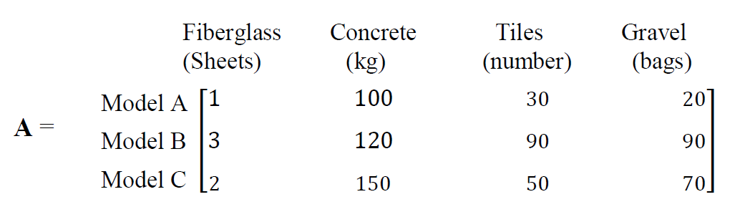

a) Swimming’s Cool receives the following orders: 4 of Model A, 2 of Model B

and 1 of Model C. Create matrix **B** to represent this information.

b) Use matrix methods to calculate the total amount of each material needed to fill the order.

c) The costs for each of the materials are as follows:

Fiberglass Concrete Tiles Gravel

($300/Sheet) ($50/kg)\ ($5 each) ($70/bag)

Calculate, **using matrix methods and showing full working**, the total cost of the order.

**End of Test**